Glossary – Notes About Security – Security List

Glossary

Notes

Category for Eval: Command Injection, Cross-site scripting (XSS)

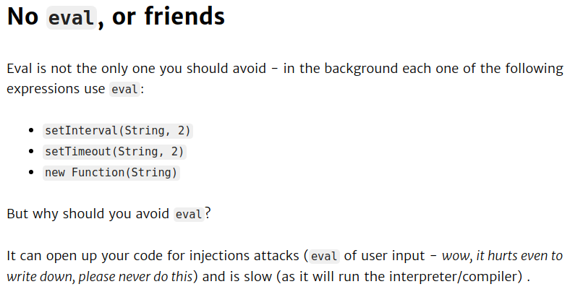

Information about eval()
Syntax:
eval(String)

Definition:
The eval() function evaluates JavaScript code represented as a string.

Return Value:
The completion value of evaluating the given code. If the completion value is empty, undefined is returned.

Why No Eval or Friends →

JavaScript is an interpreted language, and like so many of its peers it includes the all powerful eval() function. eval()takes a string and executes it as if it were regular JavaScript code. It’s incredibly powerful and incredibly easy to abuse in ways that make your code slower and harder to maintain. As a general rule, if you’re using eval() there’s probably something wrong with your design.

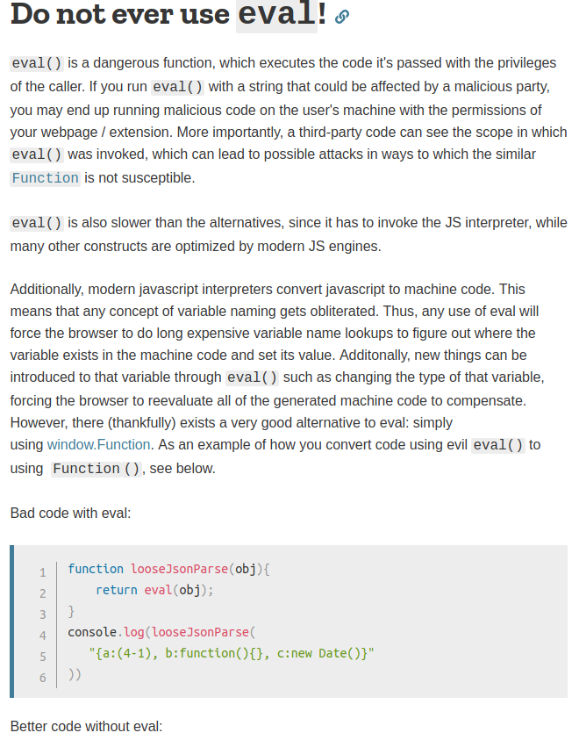

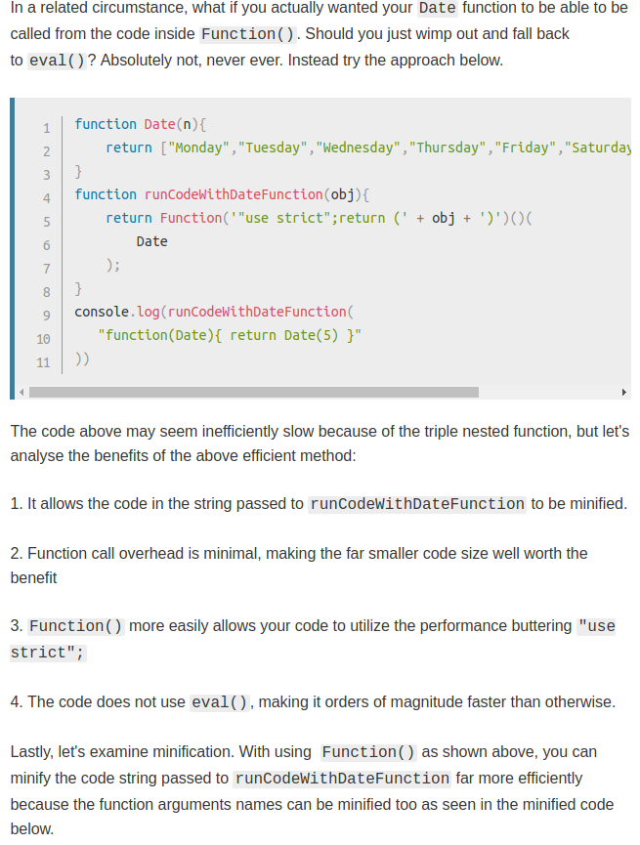
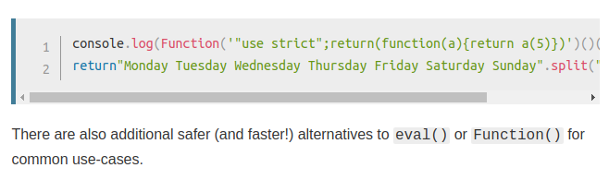
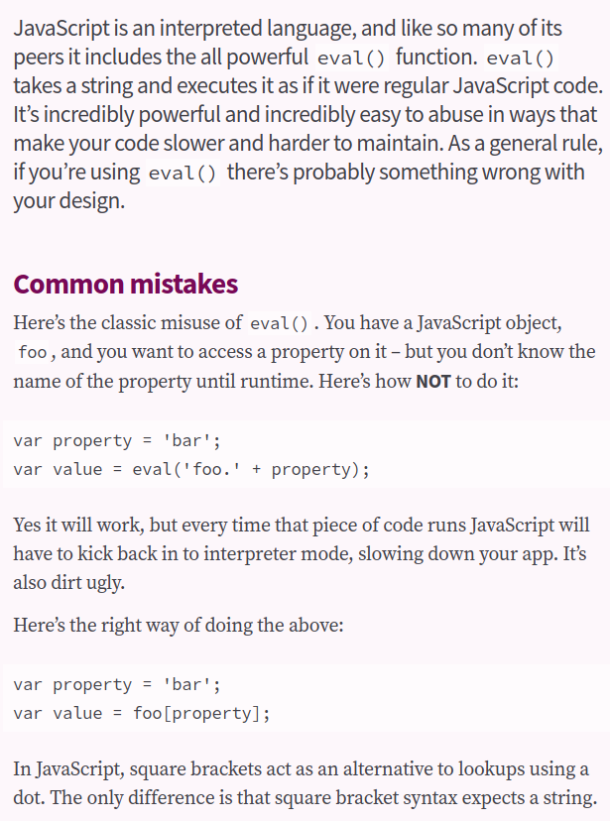

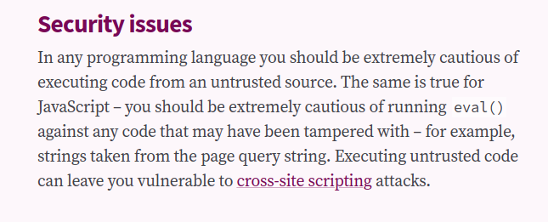
Here’s a list of applications in which you must use eval():
- Running code remotely sent from a server
- Evaluating user input code**
- Running dynamically generated code
- Running a script and storing its result

**While applications 1,3, and 4 are generally safe, there are real security concerns to our second application — evaluating user input code.

Using eval() does not automatically open you up to a Cross-Site Scripting (XSS) attack nor does it mean there is some lingering security vulnerability that you’re not aware of. Just like any tool, you need to know how to wield it correctly, but even if you use it incorrectly, the potential for damage is still fairly low and contained.

When eval() is unavoidable?
Let's say you have some raw text, and some of that text is JS, you could use eval() to turn the quoted JavaScript back into JavaScript and execute it. When that is the task you need to do, eval() is the only thing that will work, but it's very rare that you're needing to execute quoted JavaScript code from another language (and this should be done with caution when you do).

Conclusion:
Eval Should never be used when any of the input is out of control!

References:
https://developer.mozilla.org/en-US/docs/Web/JavaScript/Reference/Global_Objects/eval

https://blog.risingstack.com/node-js-security-tips/

https://stackoverflow.com/questions/4599857/are-eval-and-new-function-the-same-thing

https://24ways.org/2005/dont-be-eval

https://stackoverflow.com/questions/86513/why-is-using-the-javascript-eval-function-a-bad-idea

https://medium.com/@eric_lum/the-dangerous-world-of-javascripts-eval-and-encoded-strings-96fd902af2bd
https://humanwhocodes.com/blog/2013/06/25/eval-isnt-evil-just-misunderstood/

Category for child_process.exec(): Command Injection

Definition:

Syntax:

Why not child_process.exec() →
Merge the other .odt file from Documents

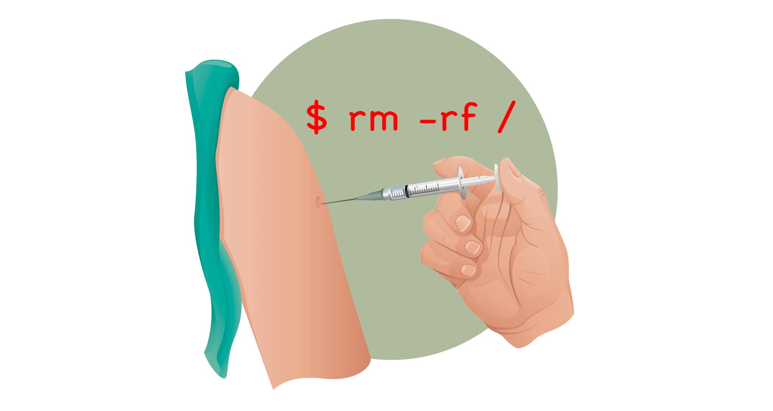

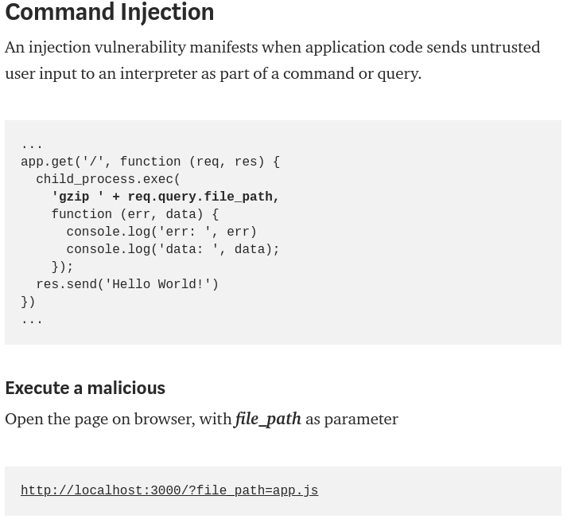
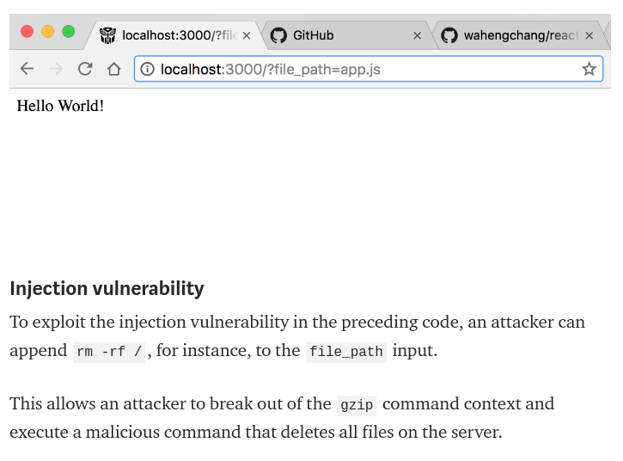
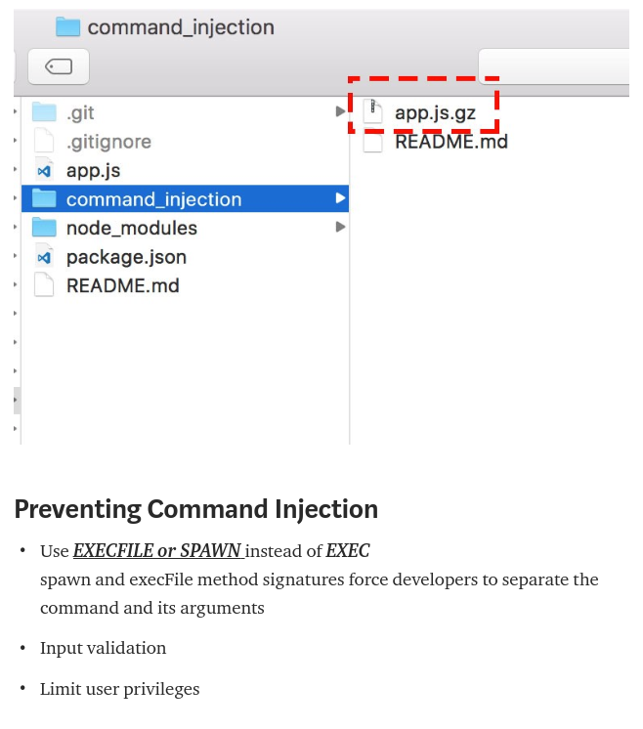

Security List
Command Injection:

Rules:
- child_process.exec()

*Merge the other .odt file with this one!

Information:
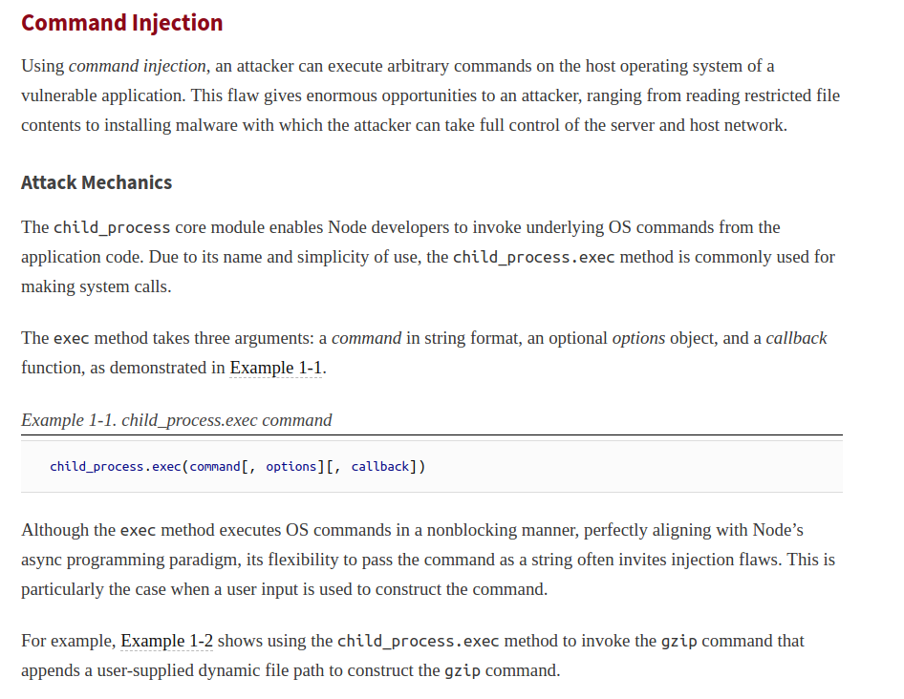
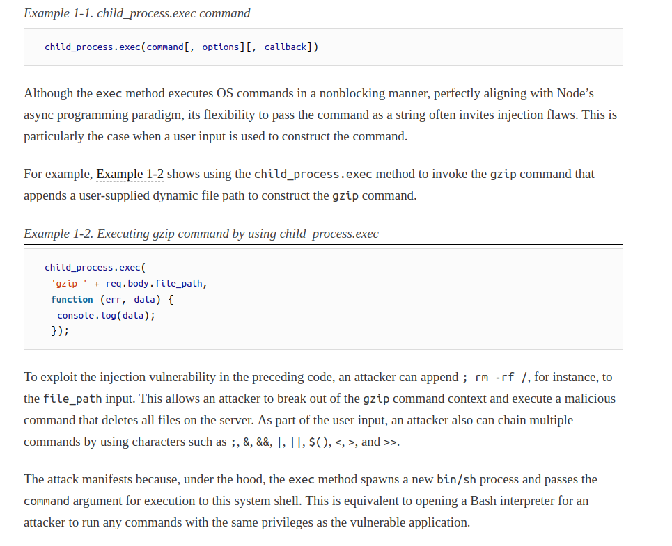

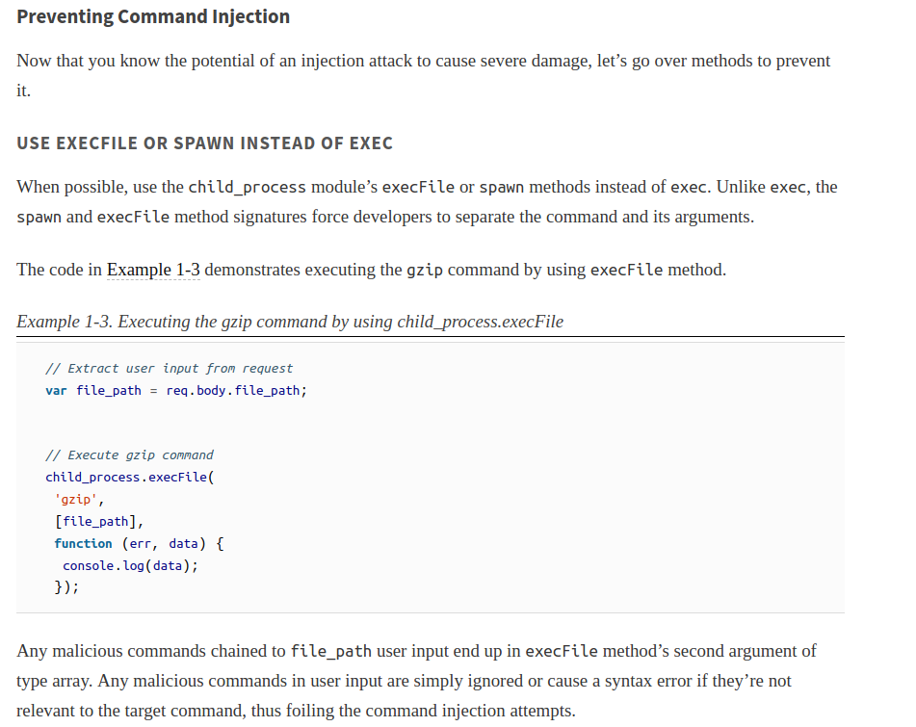

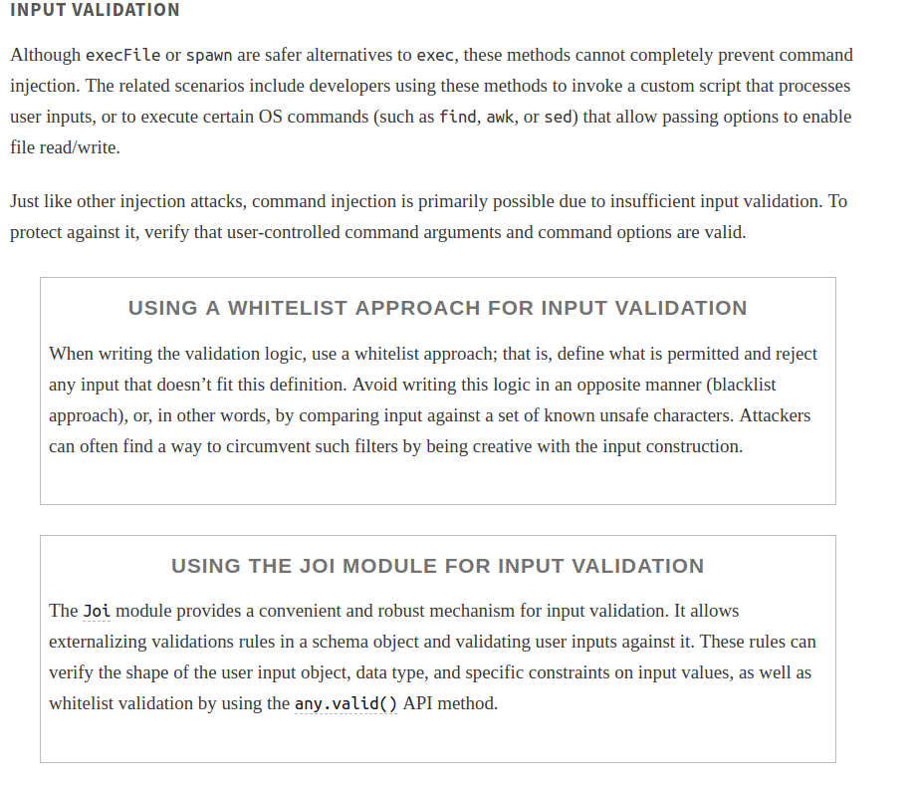

Cross-site-scripting(XSS):

Rules:
- eval() ?

SQL Injection:

Rules:
- Dynamically constructed aql query that is vulnerable to sql injection!

Information:

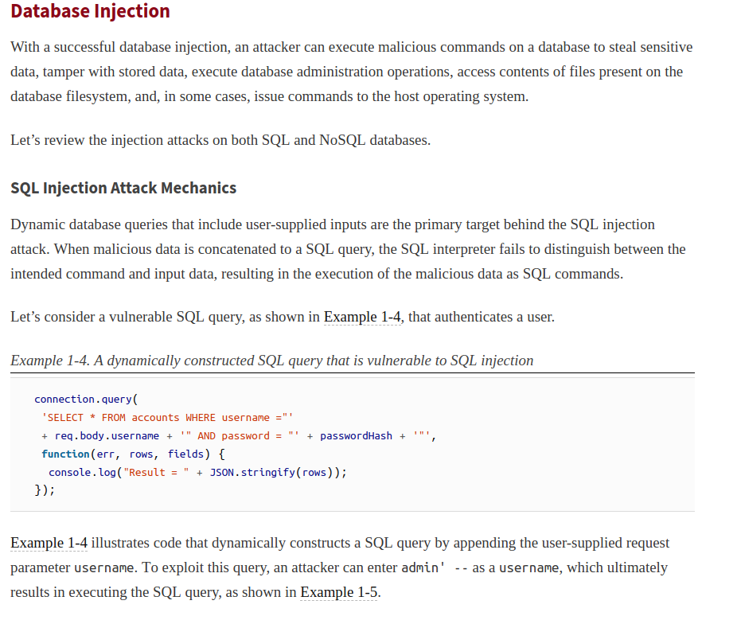

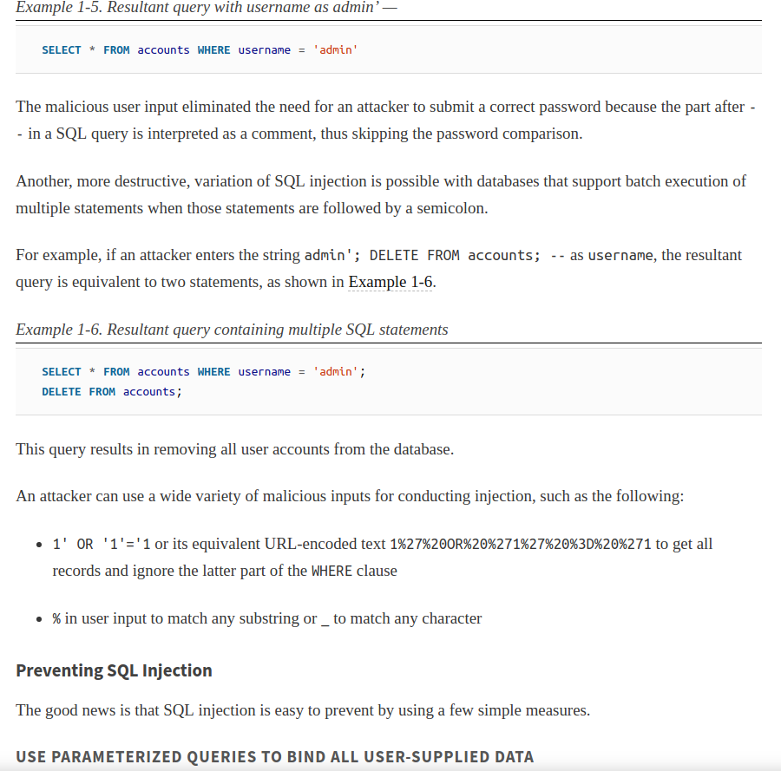

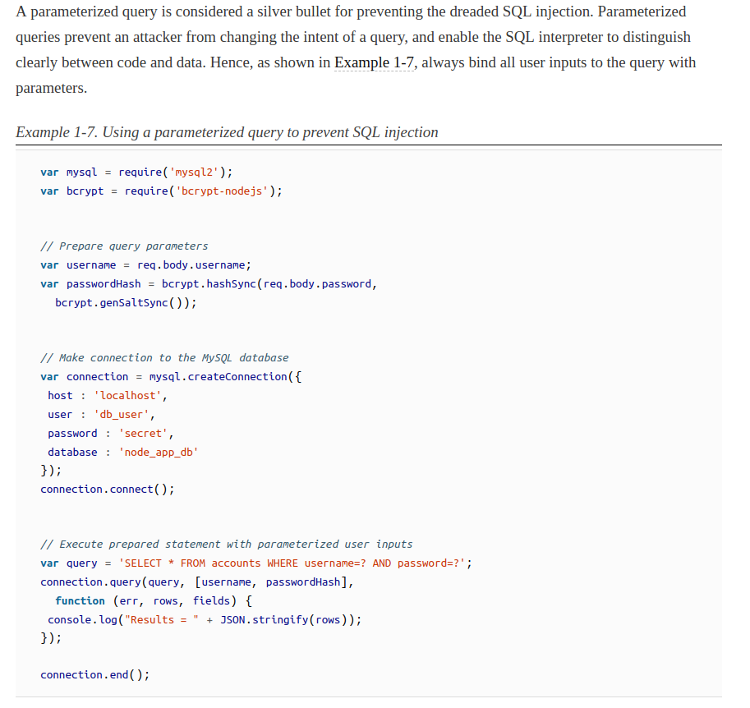

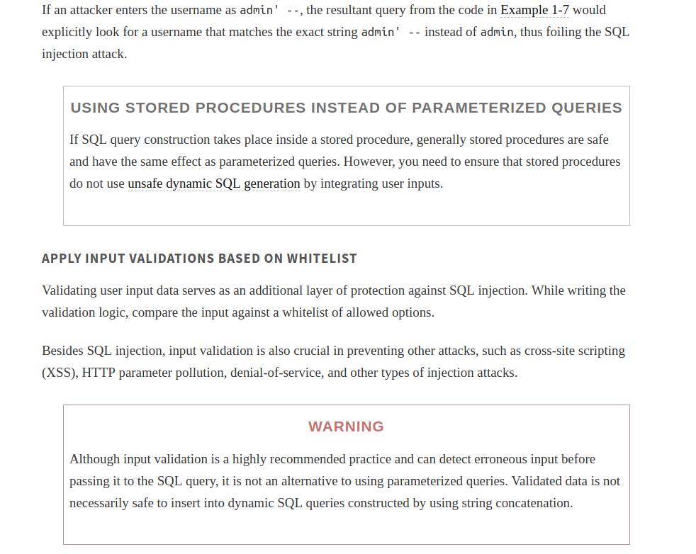

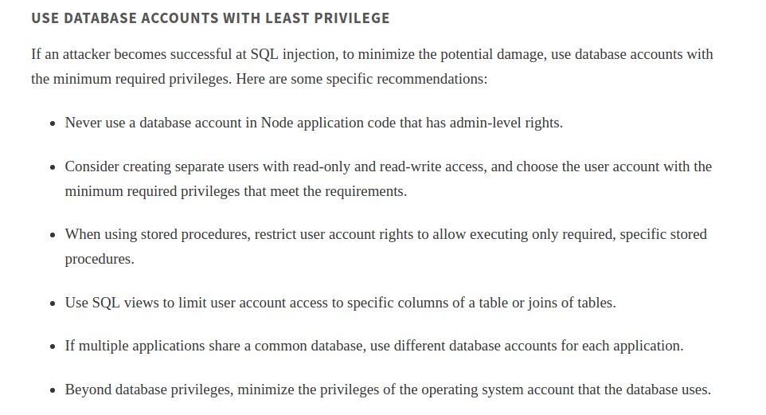

Insecure Randomness:

Rules:
- Do not use Math.Random()

Information:

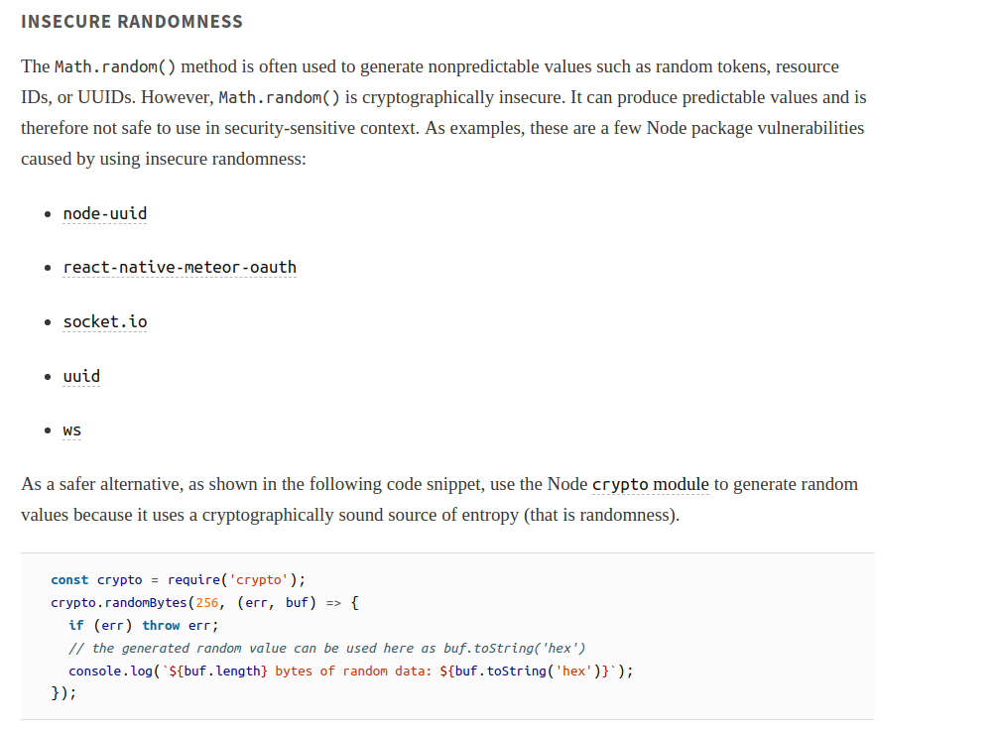

Directory Traversal:
Rule : Do not use UserInput to construct the path of the resources on the system!
Information:
Try to find non Literal value of the filename parameter in fs calls!

